DAY-2 CSS  
cascading style sheet

CSS are three types

1. Internal : these are written in “ <style> </style>”

<style>

        body{

            margin: 0;

            padding: 0;

    </style>

1. External : These are written in external file .css .

Step1:

<link *rel*="stylesheet" *href*="style.css">

Step 2:

1. Inline : These are written in with in the tag.

Color:

RGB : color: rgb(22, 40, 40);

Hdecimal : #0b03ff

Precedence: style wrote in top execute first after that it is override by next style

Selectors:

Byelement

ById

By clasname

grouping

Universal

Using id to change col:

<style>

*#para*{

    }

</style>

<p *id*="para"></p>

Universal;

*{

    universal

}

Classname:

<p *class*="para">budaa</p>

<style>

*.para*{

        color: red;

    }

Variable:

*:root*{

    --pare:red;

}

p,pare{

    color: var(--pare);

}

Div:

It is used to make partitions in the web page

Like padding margin and border

<div *class*="box"></div>

*.box*{

        background:rgb(243, 250, 243);

        width: 100px;

        height: 50px;

        margin: 5px;

        border: solid red 3px;

        padding: 20px;

}

Top bottom right left:

  margin: 100 20 10 500;

dt:23/7/24

JavaScript

intro: JavaScript is the versatile language used for creating interactive web pages and web app. It adds dynamic functionality to static web page.

Scripting language are which are used to develop in server is called scripting language

Variable and data types:

* Integers
* Characters
* Array
* String
* Boolean

Control flow and conditional statement:

* If
* Else
* Else if
* While
* For

Function and scope: It’s a reusable block of code that perform specific task.

Scope refers the

Let, var and const:

Var function scoped can be reassigned.

older way to declare the variable.

Array anf object:

DOM Manipulation: Document Object Model represent the HTML structure of a web page as a tree.

Js can manipulate this tree to interact with element and modify their content.

We can dom manipulate by tag, id & class

**<p id="demo" > </p>**

**document.getElementById("demo").innerText="java";**

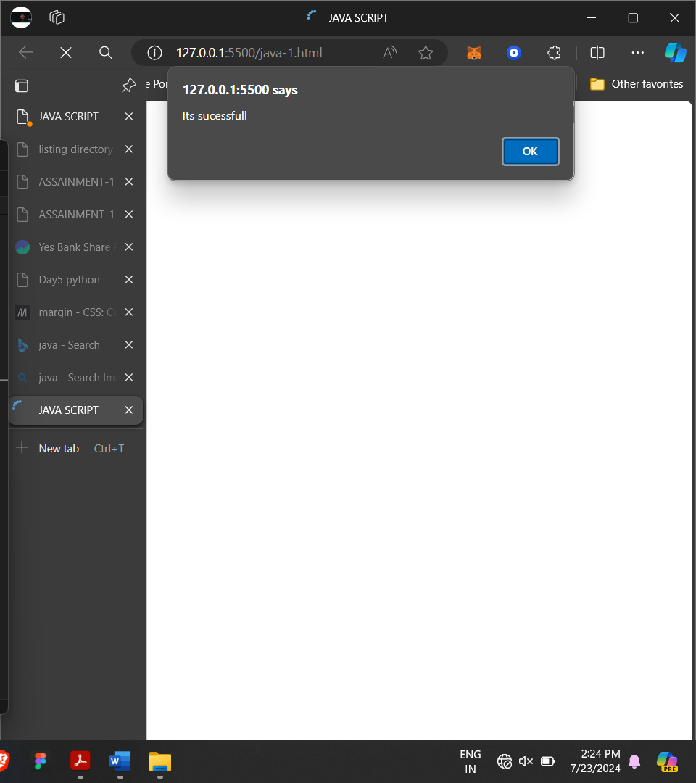

Alert have priority order to execute first.

Printing single

